First Contact Physiotherapist
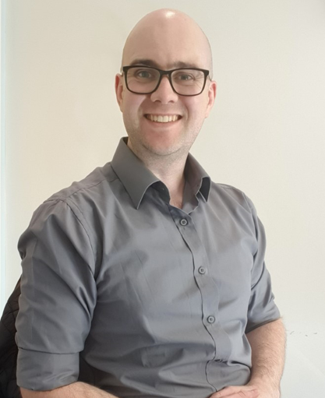
Introducing our new First Contact Physiotherapist – Andrew Lowes BSc MCSP
Andrew, our First Contact Physiotherapist will be providing support to patients who are suffering from any bone, joint or muscle pain. Including pain induced by exercise and as a result of widespread complex pain such as fibromyalgia or generalised chronic pain. This includes:
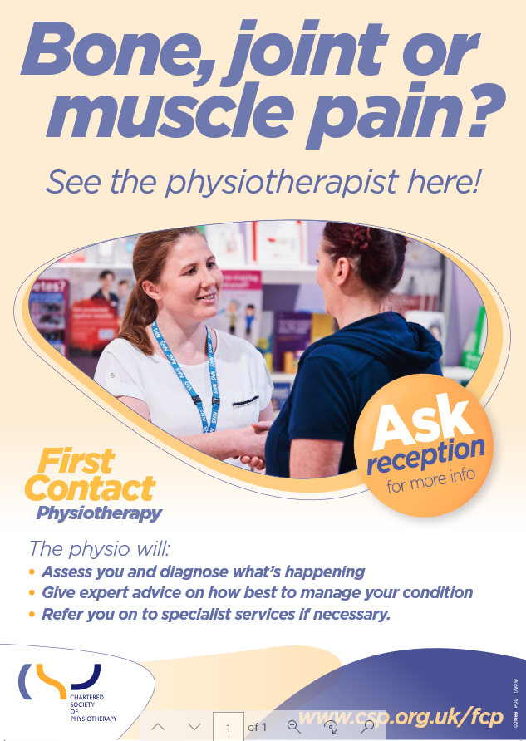
- Low Back Pain
- Sciatica
- Neck Pain
- Arthritis Symptoms
- Hip, Knee and Ankle Pain
- Shoulder, Elbow, Wrist and Hand Pain
- Acute Injuries and Falls
- Sprains and Strains Sports Injuries
- Problems with Mobility and Activity
- Work Related Pain
- Posture Related Pain
- Persistent or Chronic Pain (inc. Fibromyalgia)
- Other types of pain
- Provide General Health and Lifestyle Advice

Andrew will be available for patients to book appointments with from XXXXXX

